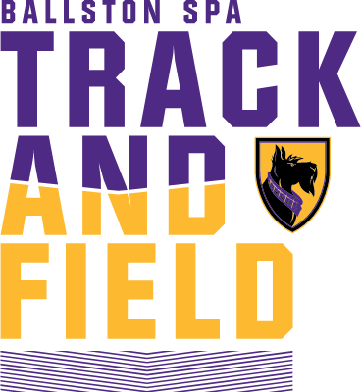
BALLSTON SPA FIELD EVENTS INVITE
MONDAY APRIL 6
BALLSTON SPA HIGH SCHOOL
9:00 START TIME
DISCUS – JAVELIN - SHOT PUT
LONG JUMP - TRIPLE JUMP
HIGH JUMP - POLE VAULT
THROWERS 4X100
ORDER: DISCUS BOYS FOLLOWED BY GIRLS
SHOT PUT GIRLS FOLLOWED BY BOYS
JAVELIN OPEN PIT GIRLS JAVELINS WILL BE PROVIDED IF NEEDED
JAVELIN OPEN PIT BOYS JAVELINS WILL BE PROVIDED IF NEEDED
HIGH JUMP GIRLS FOLLOWED BY BOYS
GIRLS OPENING HEIGHT 3’6 UP BY 3” BOYS OPENING HEIGHT 4’6”
POLE VAULT BOYS FOLLOWED BY GIRLS OPENING HEIGHT 6’ UP BY 6”
LONG JUMP GIRLS FOLLOWED BY BOYS
TRIPLE JUMP BOYS FOLLOWED BY GIRLS
THROWERS 4X100 MUST HAVE AT LEAST 2 THROWERS
AWARDS: MEDALS TO THE TOP 6 IN EACH EVENT
THROWERS 4X100 MEDALS TOP 3 TEAMS
ATTEMPTS: 4 THROWS D-J-SP 4 JUMPS LJ-TJ NORMAL HJ-PV
FEE: $ 240 PER SCHOOL $ 150 SINGLE SEX TEAM
FEE: $ 20 PER EVENT
ENTRIES: Limit 7 per team for each event
REGISTER: NY.MILESPLIT.COM ENTRIES DUE APRIL 3 @ 11:00 PM

BALLSTON SPA FIELD CHALLENGE

BOYS____ GIRLS____

FULL TEAM $ 240 SINGLE SEX: $ 150

CHECKS MADE PAYABLE TO:

Parents of Scotties Cross Country and Track
330 Brownell Road
Malta, NY 12020

Any School entering the Javelin must provide
COI Naming Ballston Spa, needs to be emailed to:
gpreece@bscsd.org
518-852-3320

Please email your intent to compete as soon as possible:
Garry Preece

